For this assignment , I have created an AnimePage where you can get information about you favourite anime characters.

The link below allows you to enter the webpage I’ve created :

<https://tushar2001-chiro.github.io/>

For this , I’ve made use of Visual Studio Code for coding the webpage.

I have used HTML , CSS and Javascript to make the page interactive.

First ,

1) I have created a main HTML document named index.html which is the main webpage.

2) Here , I’ve coded the css in the <style> tag and Javascript in the <script> tag.

3) I’ve added a background picture and two pictures of my favourite anime characters.

The webpage index.html is as follows :

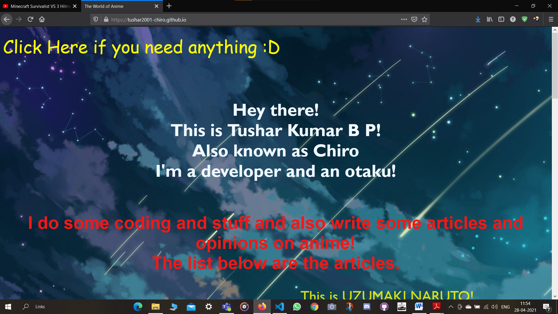

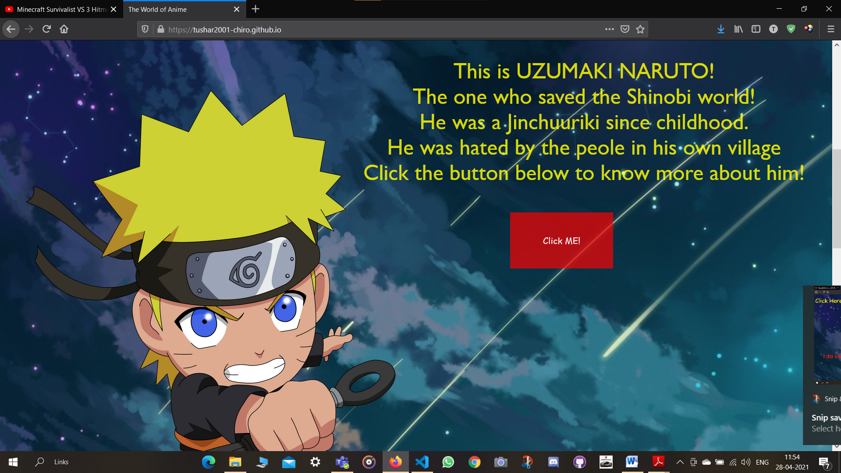

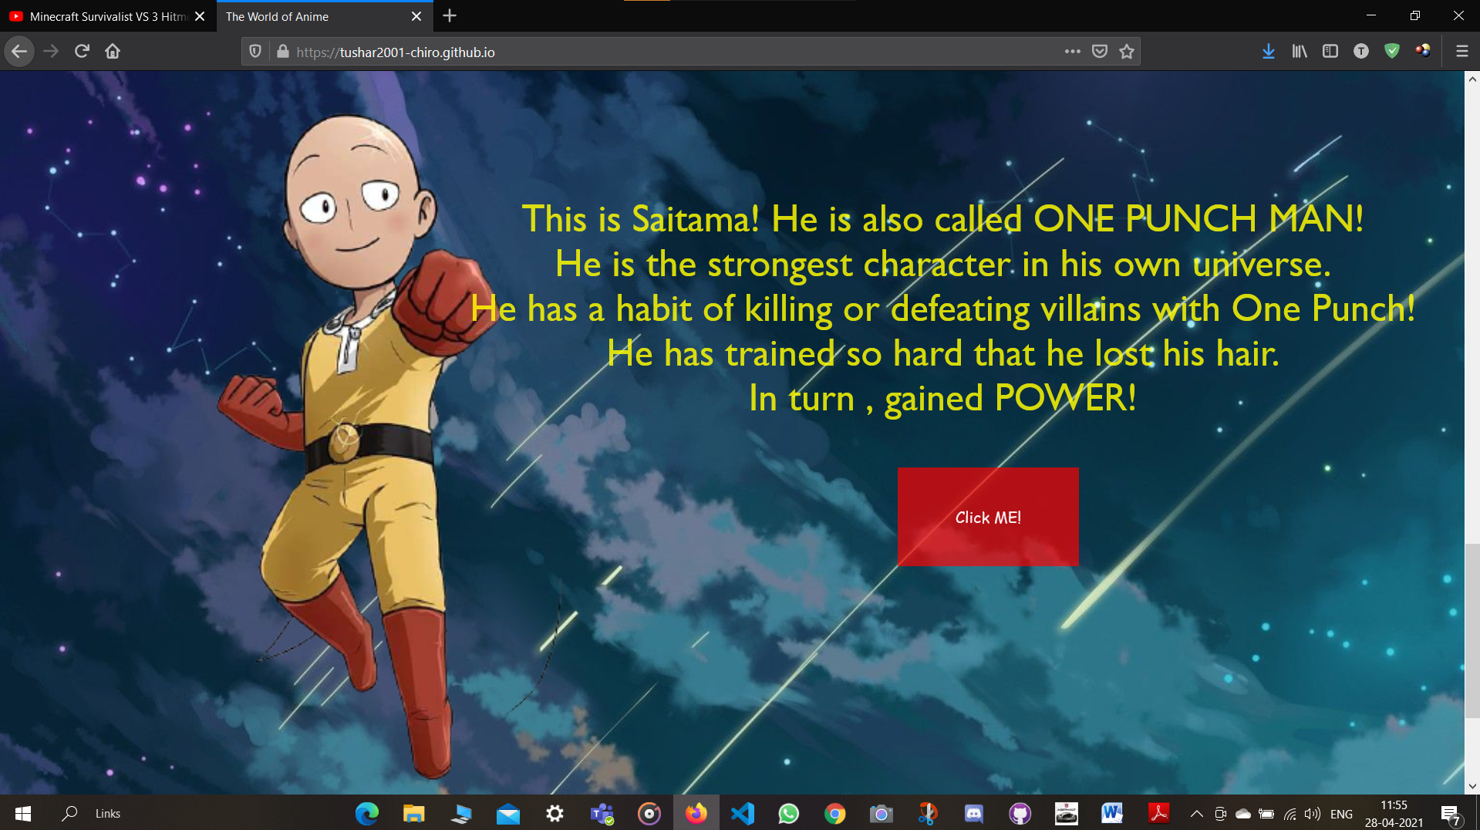

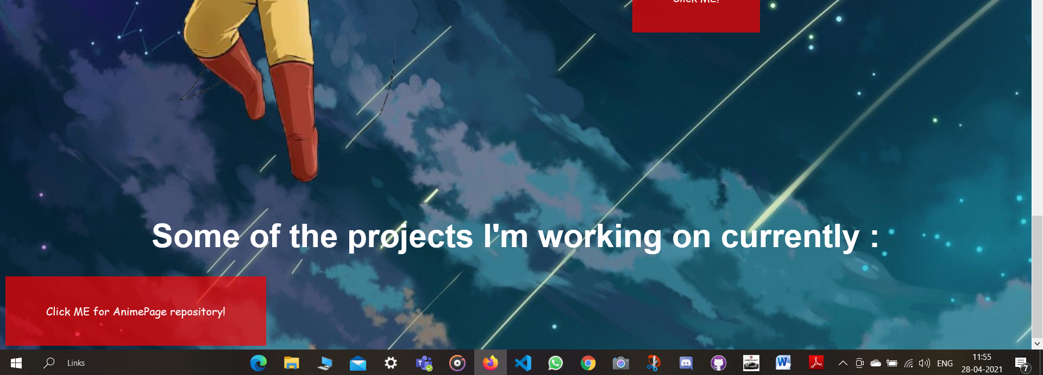

Clicking on “Click ME for ANimePage Repository” will open the Repository in Github

For now , I’ve provided the links of other websites in the “Click Me!” Button that will take you to other webpages having info.

There’s also a “Click me if you need anything! :D” where a sidebar appears as soon as you click it!

Here , I’ve provided 4 buttons. Here only two of them work.

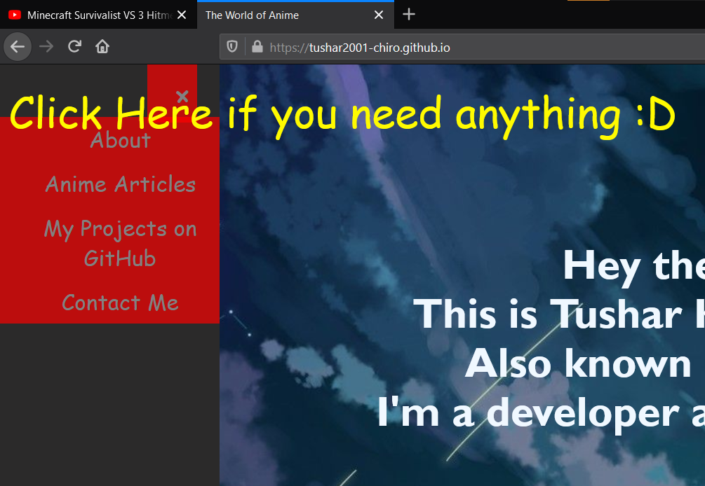

Pressing on Anime Articles will take you to the Anime articles webpage :

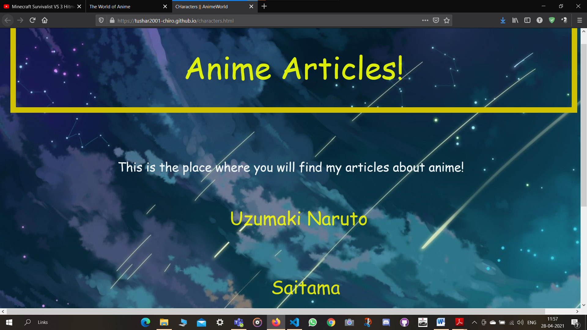

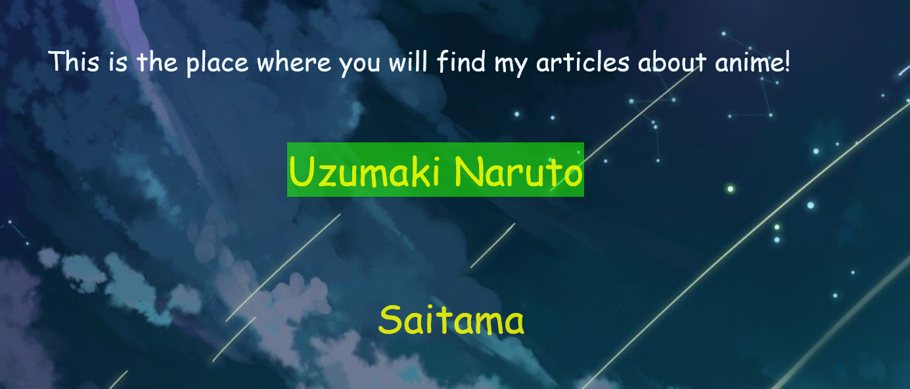

Pressing on any two of these buttons will take you back to the main page i.e index.html.

Clicking on My Projects on Github will open my repositories section in GitHub.



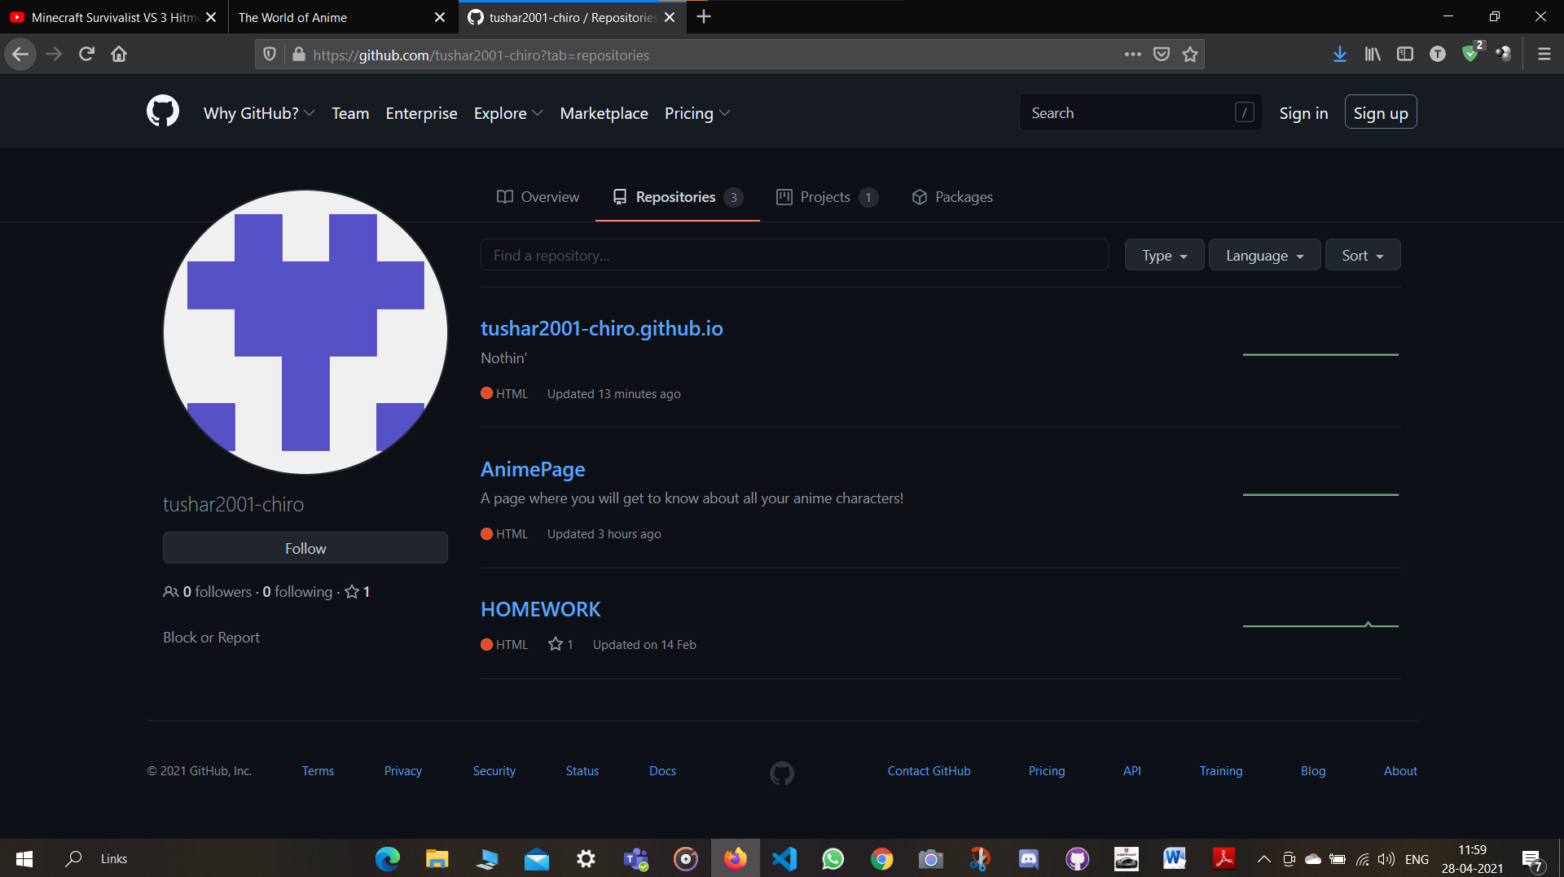

**THANK YOU!**